**Network Technologies IT51**

**MCA-FY**

**Chapter-02**

**Layered Architecture**

Networking engineering is a complicated task, which involves software, firmware, chip level engineering, hardware, and electric pulses. To ease network engineering, the whole networking concept is divided into multiple layers. Each layer is involved in some particular task and is independent of all other layers. But as a whole, almost all networking tasks depend on all of these layers. Layers share data between them and they depend on each other only to take input and send output.

## Layered Architecture

* The main aim of the layered architecture is to divide the design into small pieces.
* Each lower layer adds its services to the higher layer to provide a full set of services to manage communications and run the applications.
* It provides modularity and clear interfaces, i.e., provides interaction between subsystems.
* It ensures the independence between layers by providing the services from lower to higher layer without defining how the services are implemented. Therefore, any modification in a layer will not affect the other layers.
* The number of layers, functions, contents of each layer will vary from network to network. However, the purpose of each layer is to provide the service from lower to a higher layer and hiding the details from the layers of how the services are implemented.
* The basic elements of layered architecture are services, protocols, and interfaces.
  + Service: It is a set of actions that a layer provides to the higher layer.
  + Protocol: It defines a set of rules that a layer uses to exchange the information with peer entity. These rules mainly concern about both the contents and order of the messages used.
  + Interface: It is a way through which the message is transferred from one layer to another layer.
* In a layer n architecture, layer n on one machine will have a communication with the layer n on another machine and the rules used in a conversation are known as a layer-n protocol.

In **layered architecture** of **Network** Model, one whole **network** process is divided into small tasks. Each small task is then assigned to a particular **layer** which works dedicatedly to process the task only. Every **layer** does only specific work.

**ISO OSI Model**

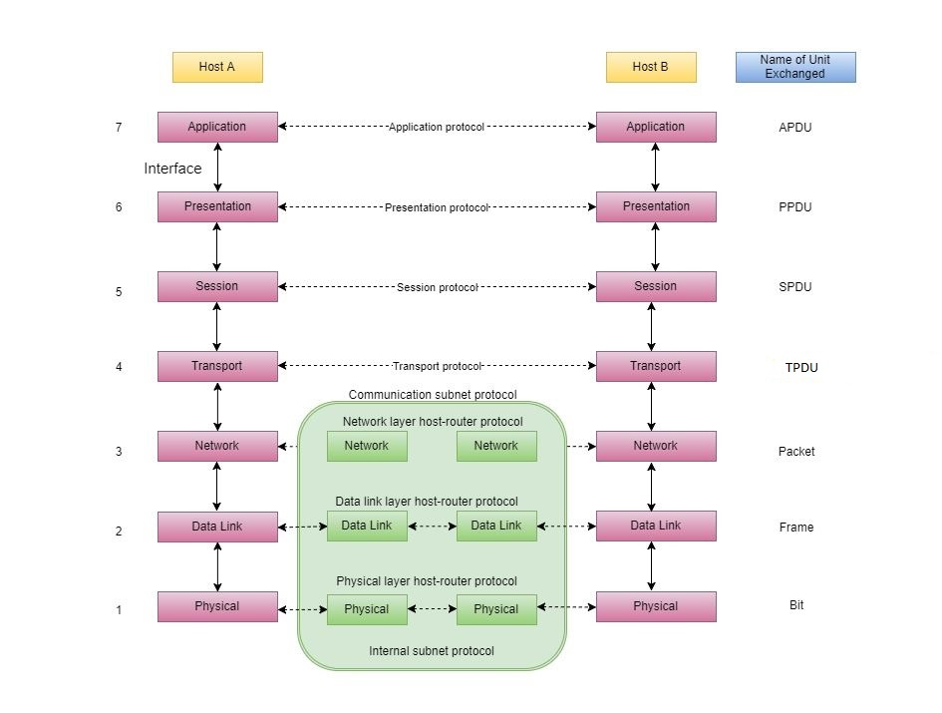

**1. Physical Layer (Layer 1) :**

The lowest layer of the OSI reference model is the physical layer. It is responsible for the actual physical connection between the devices. The physical layer contains information in the form of bits. It is responsible for transmitting individual bits from one node to the next. When receiving data, this layer will get the signal received and convert it into 0s and 1s and send them to the Data Link layer, which will put the frame back together.

The functions of the physical layer are :

1. **Bit synchronization:** The physical layer provides the synchronization of the bits by providing a clock. This clock controls both sender and receiver thus providing synchronization at bit level.
2. **Bit rate control:** The Physical layer also defines the transmission rate i.e. the number of bits sent per second.
3. **Physical topologies:** Physical layer specifies the way in which the different, devices/nodes are arranged in a network i.e. bus, star or mesh topolgy.
4. **Transmission mode:** Physical layer also defines the way in which the data flows between the two connected devices. The various transmission modes possible are: Simplex, half-duplex and full-duplex.

* Hub, Repeater, Modem, Cables are Physical Layer devices.

** Network Layer, Data Link Layer and Physical Layer are also known as **Lower**

**Layers** or **Hardware Layers**.

**2. Data Link Layer (DLL) (Layer 2) :**

The data link layer is responsible for the node to node delivery of the message. The main function of this layer is to make sure data transfer is error-free from one node to another, over the physical layer. When a packet arrives in a network, it is the responsibility of DLL to transmit it to the Host using its MAC address.  
Data Link Layer is divided into two sub layers :

1. Logical Link Control (LLC)
2. Media Access Control (MAC)
3. The packet received from Network layer is further divided into frames depending on the frame size of NIC(Network Interface Card). DLL also encapsulates Sender and Receiver’s MAC address in the header.
4. The Receiver’s MAC address is obtained by placing an ARP(Address Resolution Protocol) request onto the wire asking “Who has that IP address?” and the destination host will reply with its MAC address.

The functions of the data Link layer are :

1. **Framing:**Framing is a function of the data link layer. It provides a way for a sender to transmit a set of bits that are meaningful to the receiver. This can be accomplished by attaching special bit patterns to the beginning and end of the frame.
2. **Physical addressing:** After creating frames, Data link layer adds physical addresses (MAC address) of sender and/or receiver in the header of each frame.
3. **Error control:** Data link layer provides the mechanism of error control in which it detects and retransmits damaged or lost frames.
4. **Flow Control:** The data rate must be constant on both sides else the data may get corrupted thus , flow control coordinates that amount of data that can be sent before receiving acknowledgement.
5. **Access control:**When a single communication channel is shared by multiple devices, MAC sub-layer of data link layer helps to determine which device has control over the channel at a given time.
6. * Packet in Data Link layer is referred as ***Frame***.** Data Link layer is handled by the NIC (Network Interface Card) and device drivers of host machines.
7. *** Switch & Bridge are Data Link Layer devices.

**\3. Network Layer (Layer 3) :**

Network layer works for the transmission of data from one host to the other located in different networks. It also takes care of packet routing i.e. selection of the shortest path to transmit the packet, from the number of routes available. The sender & receiver’s IP address are placed in the header by the network layer.  
The functions of the Network layer are :

1. **Routing:** The network layer protocols determine which route is suitable from source to destination. This function of network layer is known as routing.
2. **Logical Addressing:**In order to identify each device on internetwork uniquely, network layer defines an addressing scheme. The sender & receiver’s IP address are placed in the header by network layer. Such an address distinguishes each device uniquely and universally.

*\* Segment*in Network layer is referred as **Packet**.  
https://media.geeksforgeeks.org/wp-content/uploads/computer-network-osi-model-layers-packet.png  
** Network layer is implemented by networking devices such as routers.

**4. Transport Layer (Layer 4) :**

Transport layer provides services to application layer and takes services from network layer. The data in the transport layer is referred to as *Segments*. It is responsible for the End to End Delivery of the complete message. The transport layer also provides the acknowledgement of the successful data transmission and re-transmits the data if an error is found.  
**• At sender’s side:**  
Transport layer receives the formatted data from the upper layers, performs **Segmentation** and also implements **Flow & Error control** to ensure proper data transmission. It also adds Source and Destination port number in its header and forwards the segmented data to the Network Layer.  
Note: The sender need to know the port number associated with the receiver’s application.  
Generally, this destination port number is configured, either by default or manually. For example, when a web application makes a request to a web server, it typically uses port number 80, because this is the default port assigned to web applications. Many applications have default port assigned.  
**• At receiver’s side:**  
Transport Layer reads the port number from its header and forwards the Data which it has received to the respective application. It also performs sequencing and reassembling of the segmented data.

The functions of the transport layer are :

1. **Segmentation and Reassembly:** This layer accepts the message from the (session) layer , breaks the message into smaller units . Each of the segment produced has a header associated with it. The transport layer at the destination station reassembles the message.
2. **Service Point Addressing:** In order to deliver the message to correct process, transport layer header includes a type of address called service point address or port address. Thus by specifying this address, transport layer makes sure that the message is delivered to the correct process.

The services provided by the transport layer :

1. **Connection Oriented Service:** It is a three-phase process which include  
   – Connection Establishment  
   – Data Transfer  
   – Termination / disconnection  
   In this type of transmission, the receiving device sends an acknowledgement, back to the source after a packet or group of packet is received. This type of transmission is reliable and secure.
2. **Connection less service:** It is a one-phase process and includes Data Transfer. In this type of transmission, the receiver does not acknowledge receipt of a packet. This approach allows for much faster communication between devices. Connection-oriented service is more reliable than connectionless Service.

*\* Data in the Transport Layer is called as****Segments****.  
** Transport layer is operated by the Operating System. It is a part of the OS and communicates with the Application Layer by making system calls.  
Transport Layer is called as****Heart of OSI****model.*

**5. Session Layer (Layer 5) :**

This layer is responsible for establishment of connection, maintenance of sessions, authentication and also ensures security.  
The functions of the session layer are :

1. **Session establishment, maintenance and termination:** The layer allows the two processes to establish, use and terminate a connection.
2. **Synchronization :** This layer allows a process to add checkpoints which are considered as synchronization points into the data. These synchronization point help to identify the error so that the data is re-synchronized properly, and ends of the messages are not cut prematurely and data loss is avoided.
3. **Dialog Controller :** The session layer allows two systems to start communication with each other in half-duplex or full-duplex.

*\*\*All the below 3 layers(including Session Layer) are integrated as a single layer in the TCP/IP model as “Application Layer”.  
**Implementation of these 3 layers is done by the network application itself. These are also known as****Upper Layers****or****Software Layers****.*

SCENARIO:  
Let’s consider a scenario where a user wants to send a message through some Messenger application running in his browser. The “Messenger” here acts as the application layer which provides the user with an interface to create the data. This message or so-called Data is compressed, encrypted (if any secure data) and converted into bits (0’s and 1’s) so that it can be transmitted.  
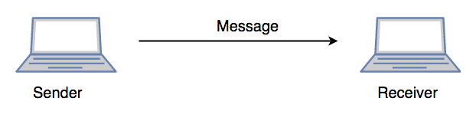

**6. Presentation Layer (Layer 6) :**

Presentation layer is also called the **Translation layer**.The data from the application layer is extracted here and manipulated as per the required format to transmit over the network.  
The functions of the presentation layer are :

1. **Translation :** For example, ASCII to EBCDIC.
2. **Encryption/ Decryption :** Data encryption translates the data into another form or code. The encrypted data is known as the cipher text and the decrypted data is known as plain text. A key value is used for encrypting as well as decrypting data.
3. **Compression:** Reduces the number of bits that need to be transmitted on the network.

**7. Application Layer (Layer 7) :**

At the very top of the OSI Reference Model stack of layers, we find Application layer which is implemented by the network applications. These applications produce the data, which has to be transferred over the network. This layer also serves as a window for the application services to access the network and for displaying the received information to the user.  
Ex: Application – Browsers, Skype Messenger etc.  
*\*\*Application Layer is also called as Desktop Layer.*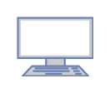The functions of the Application layer are :

1. Network Virtual Terminal
2. FTAM-File transfer access and management
3. Mail Services
4. Directory Services

OSI model acts as a reference model and is not implemented in the Internet because of its late invention. Current model being used is the TCP/IP model.

# TCP/IP Model: Layers & Protocol | What is TCP IP Stack?

## What is the TCP/IP Model?

TCP/IP stands for Transmission Control Protocol/ Internet Protocol. TCP/IP Protocol Stack is specifically designed as a model to offer highly reliable and end-to-end byte stream over an unreliable internetwork.

**TCP/IP Model** helps you to determine how a specific computer should be connected to the internet and how data should be transmitted between them. It helps you to create a virtual network when multiple computer networks are connected together. The purpose of TCP/IP model is to allow communication over large distances.

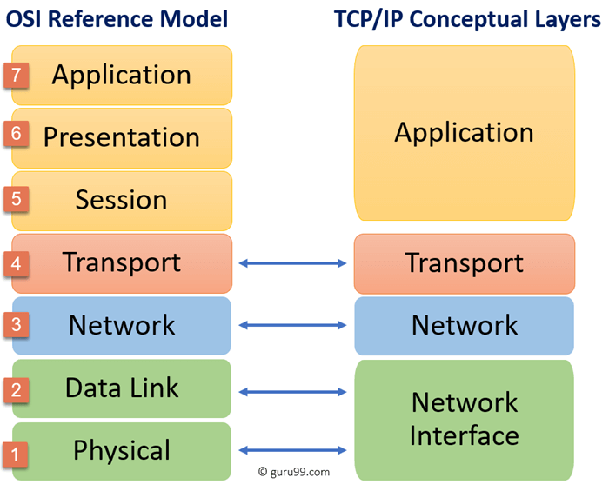

|  |  |
| --- | --- |
| **Difference between TCP/IP and OSI Model:**  *TCP/IP* | *OSI* |
| *TCP refers to Transmission Control Protocol.* | *OSI refers to Open Systems Interconnection.* |
| *TCP/IP has 4 layers.* | *OSI has 7 layers.* |
| *TCP/IP is more reliable* | *OSI is less reliable* |
| *TCP/IP does not have very strict boundaries.* | *OSI has strict boundaries* |
| *TCP/IP follow a horizontal approach.* | *OSI follows a vertical approach.* |
| *TCP/IP uses both session and presentation layer in the application layer itself.* | *OSI uses different session and presentation layers.* |
| *TCP/IP developed protocols then model.* | *OSI developed model then protocol.* |
| *Transport layer in TCP/IP does not provide assurance delivery of packets.* | *In OSI model, transport layer provides assurance delivery of packets.* |
| *TCP/IP model network layer only provides connection less services.* | *Connection less and connection oriented both services are provided by network layer in OSI model.* |
| *Protocols cannot be replaced easily in TCP/IP model.* | *While in OSI model, Protocols are better covered and is easy to replace with the change in technology.* |

**Layers of TCP IP Model**

**1. Network Access Layer –**

This layer corresponds to the combination of Data Link Layer and Physical Layer of the OSI model. It looks out for hardware addressing and the protocols present in this layer allows for the physical transmission of data.  
We just talked about ARP being a protocol of Internet layer, but there is a conflict about declaring it as a protocol of Internet Layer or Network access layer. It is described as residing in layer 3, being encapsulated by layer 2 protocols.

**2. Internet Layer –**

This layer parallels the functions of OSI’s Network layer. It defines the protocols which are responsible for logical transmission of data over the entire network. The main protocols residing at this layer are :

1. **IP –** stands for Internet Protocol and it is responsible for delivering packets from the source host to the destination host by looking at the IP addresses in the packet headers. IP has 2 versions:  
   IPv4 and IPv6. IPv4 is the one that most of the websites are using currently. But IPv6 is growing as the number of IPv4 addresses are limited in number when compared to the number of users.
2. **ICMP –** stands for Internet Control Message Protocol. It is encapsulated within IP datagrams and is responsible for providing hosts with information about network problems.
3. **ARP –** stands for Address Resolution Protocol. Its job is to find the hardware address of a host from a known IP address. ARP has several types: Reverse ARP, Proxy ARP, Gratuitous ARP and Inverse ARP.

**3. Host-to-Host Layer –**

This layer is analogous to the transport layer of the OSI model. It is responsible for end-to-end communication and error-free delivery of data. It shields the upper-layer applications from the complexities of data. The two main protocols present in this layer are :

1. **Transmission Control Protocol (TCP) –** It is known to provide reliable and error-free communication between end systems. It performs sequencing and segmentation of data. It also has acknowledgment feature and controls the flow of the data through flow control mechanism. It is a very effective protocol but has a lot of overhead due to such features. Increased overhead leads to increased cost.
2. **User Datagram Protocol (UDP) –** On the other hand does not provide any such features. It is the go-to protocol if your application does not require reliable transport as it is very cost-effective. Unlike TCP, which is connection-oriented protocol, UDP is connectionless.

**4. Application Layer –**

This layer performs the functions of top three layers of the OSI model: Application, Presentation and Session Layer. It is responsible for node-to-node communication and controls user-interface specifications. Some of the protocols present in this layer are: HTTP, HTTPS, FTP, TFTP, Telnet, SSH, SMTP, SNMP, NTP, DNS, DHCP, NFS, X Window, LPD. Have a look at [Protocols in Application Layer](https://www.geeksforgeeks.org/protocols-application-layer/) for some information about these protocols. Protocols other than those present in the linked article are :

**the differences between the OSI and TCP/IP model in a tabular form:**

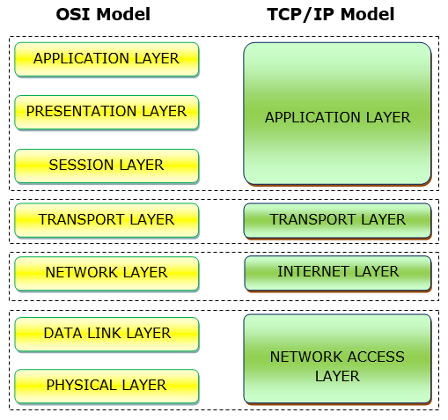

|  |  |
| --- | --- |
| OSI Model | TCP/IP Model |
| It stands for Open System Interconnection. | It stands for Transmission Control Protocol. |
| OSI model has been developed by ISO (International Standard Organization). | It was developed by ARPANET (Advanced Research Project Agency Network). |
| It is an independent standard and generic protocol used as a communication gateway between the network and the end user. | It consists of standard protocols that lead to the development of an internet. It is a communication protocol that provides the connection among the hosts. |
| In the OSI model, the transport layer provides a guarantee for the delivery of the packets. | The transport layer does not provide the surety for the delivery of packets. But still, we can say that it is a reliable model. |
| This model is based on a vertical approach. | This model is based on a horizontal approach. |
| In this model, the session and presentation layers are separated, i.e., both the layers are different. | In this model, the session and presentation layer are not different layers. Both layers are included in the application layer. |
| It is also known as a reference model through which various networks are built. For example, the TCP/IP model is built from the OSI model. It is also referred to as a guidance tool. | It is an implemented model of an OSI model. |
| In this model, the network layer provides both connection-oriented and connectionless service. | The network layer provides only connectionless service. |
| Protocols in the OSI model are hidden and can be easily replaced when the technology changes. | In this model, the protocol cannot be easily replaced. |
| It consists of 7 layers. | It consists of 4 layers. |
| OSI model defines the services, protocols, and interfaces as well as provides a proper distinction between them. It is protocol independent. | In the TCP/IP model, services, protocols, and interfaces are not properly separated. It is protocol dependent. |
| The usage of this model is very low. | This model is highly used. |
| It provides standardization to the devices like router, motherboard, switches, and other hardware devices. | It does not provide the standardization to the devices. It provides a connection between various computers. |